Specificatiile proiectului

**Scenariul de proiect**

Ne-am dori o aplicatie prin care oamenii refugiati/afectati de razboi sa poata gasi mai usor cazare. Vor exista gazde si oaspeti care pot utiliza aplicatia numai daca au un cont creat.

Gazdele pot posta un anunt pentru cazare, iar oaspetii pot cauta cazari.

Pentru a posta un anunt, o gazda trebuie sa completeze un formular cu următoarele detalii:

* Adresa cazarii
* Numarul de telefon al gazdei
* Titlul si descrierea listarii
* Numarul de persoane pentru care e disponibila cazarea
* Numar de dormitoare
* Servicii extra, cum ar fi mancare/transport/servicii medicale/suport psihologic
* Detalii suplimentare (tipul de acomodare(casa, apartament etc), tipul spatiului(intreg, o camera etc))
* Poza cu locul respectiv

Pentru a gasi acomodare, utilizatorul completeaza in bara de cautare urmatoarele detalii:

* Destinatia dorita
* Numarul de persoane

Utilizatorul poate filtra mai departe anunturile gasite dupa alte criterii

Dupa ce un utilizator rezerva o locatie, primeste un e-mail cu confirmarea rezervarii. Dupa rezervarea locuintei, cazarea nu mai este disponibila pentru rezervare. De asemenea, un utilizator are disponibil un formular de suport, unde poate scrie mesaj si administratorul sistemului va primi mail cu sesizarea.

Un utilizator poate vizualiza pe harta adresa cazarii.

**User Stories Host**

* As a host, I should firstly create an account with personal information before posting a listing (email, phone number)
* As a host, I would like to be able to post accomodation listings
* As a host, I would like to be able to delete accomodation listings
* As a host, for one listing, I should complete the following information:
  + Full address of the accommodation
  + Type of accommodation (apartment, house, unique space)
  + Description of accommodation
  + The type of space (entire place, private room or shared room)
  + Number of guests to welcome
  + Number of bathrooms and bedrooms
  + Additional facilities (pool, kitchen, air conditioning etc.)
  + Safety items(first aid kit, fire extinguisher, smoke alarm)
  + Pictures of the place
  + A title for the listing
  + Extra services for the refugees like medical care, food, transport, psychological support
* As a host, I should be able to review my details and modify them.

**User Stories Guest**

* As a guest, I should firstly create an account with personal information before looking for accomodation (email)
* As a guest, I should be able to search for accomodation
* As a guest, I would like to be able to filter my searches with the following information:
  + Location
  + Number of guests
* As a guest, I would like to further filter my search results by other criteria (services needed, desired type of space etc.)
* As a guest, I should be able to view the details of the search results
* As a guest, I would like to make a reservations for the desired listings
* As a guest, I should be able to report the host in case of misbehavior.
* As a guest, I would like to be able to see the world map locations of each accomodation
* As a guest I should be able to send a complaint email through the support form to the admin.

**Aplicarea tactical TDD pe proiect**

* User
* Listing
* Reservation

User poate exista fara Listing si Listing fara user, asta inseamna ca vor fi in agregate diferite.

Reservation are sens in ambele agregate:

* Userul face rezervare
* Listingul este rezervat

Constrangeri:

* As a user, I should not be able to make a reservation for a listing already reserved in the same period of time.
* As a user, I should not be able to make reservations for more than one listing in the same period of time.

Reservation trebuie sa fie legata de utilizator.

Obtinem agregatele:

1. UserReservation Aggregate, care contine 2 entitati: Users(AR) si Reservations
2. Listings Aggregate, care contine 1 entitate: Listings(AR)

**Arhitectura de domeniu**

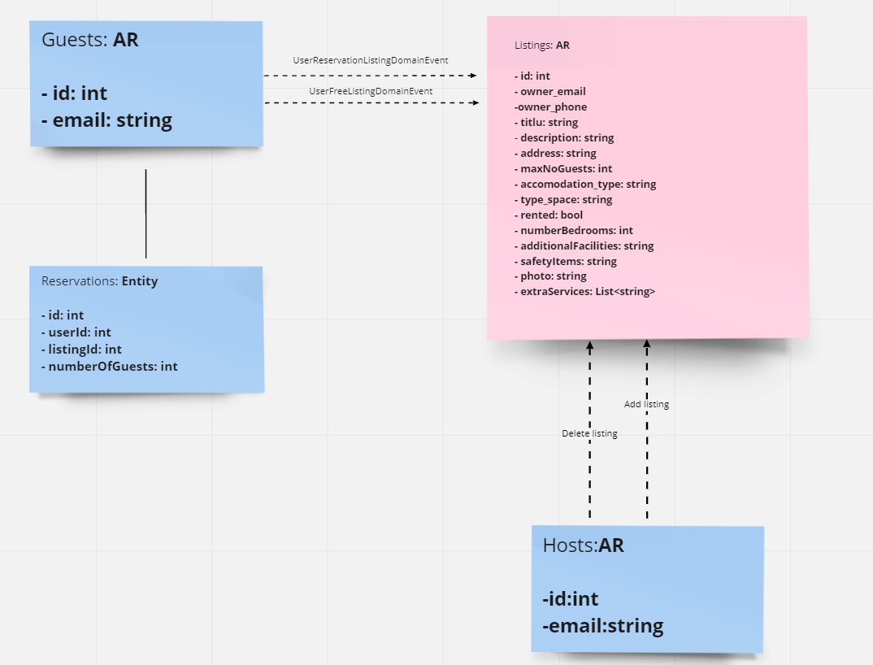

**Arhitectura macro**

